|  |
| --- |
| Photo displaying partial image of two pie charts on a canvas-textured page |
| Impact of Job loss on Economic Indicators  Analysing the Correlation Between Unemployment and GDP in New Zealand |
| |  |  | | --- | --- | | Muhammad Haziq Bin Che Rose | [Course title] | |

Analysis of the relationship between Job loss and Economic Indicators

# Table of content

* Executive Summary
* Introduction
* Methodology
* Results
* Recommendations
* Discussion
* Conclusion
* References

# Executive Summary

The summary provides an overview of the analysis of unemployment rate and GDP growth. Unemployment rate and GDP trend are critical to indicate the country’s economic health. The purpose of this report is to analyse the relationship between the unemployment rate and GDP to understand the economic trend. The analysis has revealed a strong negative correlation between the unemployment rate and GDP growth. Lower unemployment rates typically concur with higher GDP growth, which indicates a robust economy. The Policies aim is to reduce the unemployment rate to stimulate economic growth.

# Introduction

Understanding unemployment rate and GDP trends are very important because they are the key indicator of country economic performance. This report aims to analyse the relationship between unemployment and GDP growth. This document will focus on correlation, historical trends and indication, and implication for economic policies. This report includes data analysis, finding and recommendations for policy makers.

# Methadology

## Data collection

For this analysis, we collected two types of data

1. Job Loss data: This include unemployment rate for different countries, sourced from the world bank
2. Economic indicators: This include the GDP growth rate for New Zealand, provided by the international Monetary Fund (IMF)
3. Unemployment rate by age groups in New Zealand : This include unemployment rate for different age groups, sources from ILOSTAT data explorer

## Organizing the data

During this stage we want to organise the collected data into proper format

**Unemployment rate data**

The unemployment rate is available in Excel and CSV file.

The code below reads the CSV file and it only filter New Zealand data

Then data is now transformed into more proper and readable format. The python code creates a new data frame to store data and unemployment rate. Soring from the most recent to oldest.

**IMF New Zealand data**

IMF data is only available in Excel Format. The python code below reads the excel data and display the results

Creates a new data frame which contains new columns include date, GDP nominal (in millions) and GDP real (in millions). Sorting the table from the most recent to oldest

Important note:

* GDP Real reflect only quantity changes, useful for tracking growth over time by removing the effect of inflation
* GDP Nominal reflect both prices and quantity changes, useful for current size and comparison point in time.

**Merging the data tables**

Then the python code merge the IMF NZ GDP data and NZ unemployment rate data into one data frame. Then new data frame saves it to a CSV file which can found in GitHub

**Unemployment rate by age group (ILOSTAT)**

ILOSTAT data is available on csv file. The python code reads the file and create the data frame that shows the time in 2023, gender labels and classify age label.

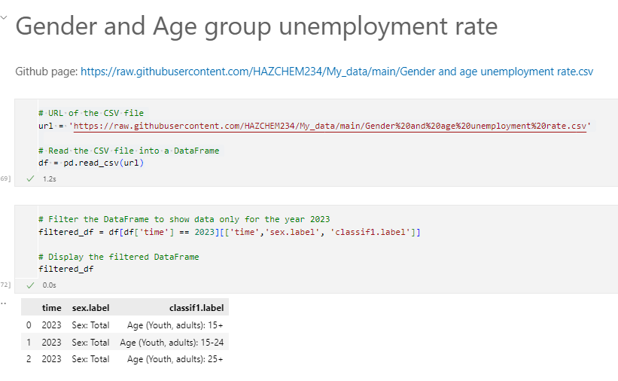

## Hypothesis testing

Hypothesis testing is uses to test if there is a significant relationship between GDP(Real) and the unemployment rate. We can define two hypothesis

* Null Hypothesis – There is no significant relationship between GDP (Real) and unemployment rate
* Alternative Hypothesis – There is a significant correlation between GDP (Real) and unemployment rate

The hypothesis testing results show that job losses have a huge influence on New Zealand's GDP. The Pearson Correlation Coefficient of -0.1917 indicates a strong negative correlation between GDP (Real) and the unemployment rate. The P-value (Probability value) is less than 0.05. It shows that there is strong evidence to reject the null hypothesis. The data has shown a significant negative correlation between the unemployment rate and the country's GDP (Real).  This means an increase in unemployment can lead to a decrease in New Zealand’s GDP (Real)

# Results

The result is to demonstrate how GDP and Unemployment rate correlate with one another.

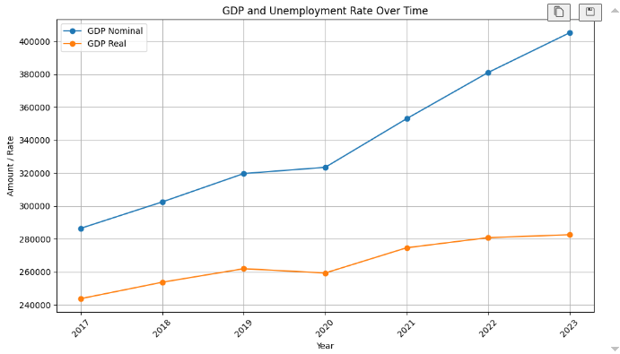

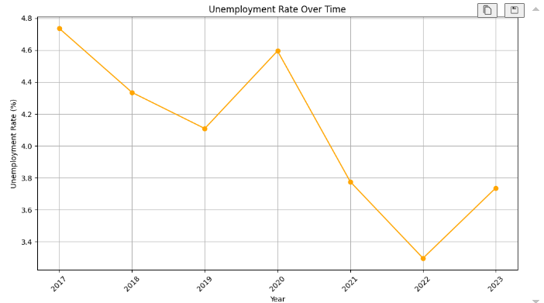

The chart shows the country economic performance and unemployment rate between 2017 to 2023.

The COVID-19 pandemic has had a huge influence on the unemployment rate and New Zealand's GDP(Real). The chart shows that there was an increase unemployment rate in the year 2020 and New Zealand's GDP dropped slightly in 2020. The COVID-19 Pandemic led to widespread economic disruption. It reduces business activity and disrupts in global supply chain. There are also reductions in consumer spending, lower business investment, decreased export and government spending cuts. This shows that COVID-19 leads to an increase in unemployment and decrease in GDP.

While COVID-19 initially reduce the country GDP and increased the unemployment, subsequent economic recovery effort has helped reduce the unemployment and increase GDP. The chart has shown that New Zealand's GDP increased, and the unemployment rate decreased from year 2020 to year 2022. This indicates that the country's economy is recovering from the contraction experienced in 2020. There is also an increase in consumer spending, business investment rebound in exports. Economic recovery has help in rise GDP, The rise in GDP is likely accompanies by job creating and a reduction in unemployment which boost the economic activity.

The working-age population, employment trends, and wage trends have influences on the unemployment rate. The chart shows there is an increase in the unemployment rate and slow GDP(Real) growth from 2022 to 2023. According to Stats NZ, the report highlights significant trends in the working-age population, employment rates, and wage increases throughout 2023. For instance:

Working-age population growth

* The working-age population grew by 124,000 (3%) over the year
* The growth was driven by net migration with more people coming to the country than leaving

Employment trend

* Employment increased by 2.4% over the year and 0.4% over the quarter.
* Despite high employment rates, the proportion of people employed decreased slightly from June 2023 due to faster population growth.

Wage trends

* Salaries and wages increase by 4.3% over
* Average hourly earnings rose 6.9%, reaching $40.84
* Average weekly earnings for full-time employees increased by 6.1%, reaching $1588

Stats NZ has shown that there is an increase in the working-age population, employment trend, and wage trends which can lead to an increase unemployment rate. At the same time, the GDP (Real) has shown slow growth from 2022 to 2023 showing that increasing unemployment slows the economy down.

# Recommendations

Investing in education and training can help reduce the unemployment rate.  According to Investopedia articles on How Education and Training Affect the economy, it states that:

.

‘The education and training of a country workforce is a major factor in determining how well the country’s economic performances.’ - Investopedia.

Enhance vocational training, internships, apprenticeships, and re-skilling programs to match the evolving needs of the labour market. Focus training on high sectors such as technology, healthcare, and renewable energy will be very beneficial to the economy.

Promoting entrepreneurship and innovation can help create more new jobs and reduce the unemployment rate.  The chart shows that young people between the ages of 15-24 are more unemployed than people above 25 years of age.

According to World Economic Forum articles ‘To address youth unemployment, we need to shift youth’s effort from seeking jobs to creating marketable opportunities for themselves. Integrating entrepreneurship and innovation into education is key. Business incubation centres and government support can drive market creation and innovation.’.  The lack of employment opportunities is a serious concern all over the world. Promote entrepreneurship and innovation by creating a supportive environment for start-ups through funding, network opportunities, and mentorship. Encourage Innovation by supporting research and development initiatives to drive innovation and create new job opportunities. This recommendation does not only reduce the unemployment rate, but it can also drive economic growth and social well-being.

# Discussion

The result indicates a strong negative correlation between the unemployment rate and GDP Reals. Based on hypothesis testing, the Pearson correlation of 0.19, alongside a probability value (p-value) less than 0.05 strongly suggests that as unemployment increases, GDP(Real) decreases.

Understanding the relationship between GDP and the unemployment rate is important for stakeholders, policymakers, and economics because it provides insight into the economy's health.

The result shows correlation, but it does not establish causation. This analysis cannot determine that increasing unemployment directly causes GDP to fall. There may be other underlying factors that influence both GDP and unemployment rates such as government policies, technological advances, or global economic conditions.  Additionally, the data does not capture nuances of the different economic sectors which could have varying impacts on the overall correlation.

Future studies could focus on the relationship between GDP and unemployment within specific sectors such as technology, healthcare, and manufacturing. It will help identify which sectors are most sensitive to changes in employment levels and develop tailored policy interventions.

# Conclusion

This analysis explores the significant relationship between GDP (Real) and the unemployment rate. The hypothesis testing revealed that job loss has a substantial impact on the country's GDP. The Pearson Correlation of -0.19 and the probability values less than 0.05 indicate a significant negative correlation between GDP (Real) and the unemployment rate.

Key points from the analysis include the observation that:

* The COVID-19 pandemic led to an increase in the unemployment rate and a slight drop in GDP in 2020
* The economic recovery effort from 2020 to 2022 help reduce unemployment and boost GDP
* However, from 2022 to 2023, there was a notable increase in the unemployment rate and slower GDP growth, influenced by factors such as working-age population growth, employment trends, and wage trends.

The findings of this analysis underscore the importance of understanding the relationship between the unemployment rate and GDP for effective policy-making and economic planning.

Addressing unemployment through education, vocational training, and promoting innovation is not only essential for economic growth. They also enhance social well-being. By creating a supportive environment for job creation and entrepreneurship, the country can ensure a robust and resilient economy capable of withstanding future challenges

# References

**Reference sources**

Stats NZ. (2024, February 7). *Unemployment rate at 4.0 percent*. Stats NZ. <https://www.stats.govt.nz/news/unemployment-rate-at-4-0-percent/#:~:text=Underemployment%20spurs%20increase%20in%20underutilisation&text=In%20the%20December%202023%20quarter%2C%20underemployment%20accounted%20for%20the%20majority,in%20the%20September%202023%20quarter>.

Stats NZ. (n.d.). Unemployment rate at 4.0 percent. Retrieved from <https://www.stats.govt.nz/news/unemployment-rate-at-4-percent>

**Data sources collected**

World Bank. (n.d.). Unemployment, total (% of total labor force) (modeled ILO estimate). Retrieved from <https://data.worldbank.org/indicator/SL.UEM.TOTL.ZS>

International Labour Organization. (n.d.). Data tools to find and download labour statistics. ILOSTAT. Retrieved from <https://ilostat.ilo.org/data/>

International Labour Organization. (n.d.). ILOSTAT Data Explorer. Retrieved from <https://ilostat.ilo.org/data/>

International Monetary Fund. (n.d.). IMF Data. Retrieved from <https://data.imf.org/?sk=4c514d48-b6ba-49ed-8ab9-52b0c1a0179b&sId=-1>

**GitHub link for data used for analysis (CSV and Excel) – this data has been transformed**

Unemployment rate age (CSV) : [raw.githubusercontent.com/HAZCHEM234/My_data/main/Gender and age unemployment rate.csv](https://raw.githubusercontent.com/HAZCHEM234/My_data/main/Gender%20and%20age%20unemployment%20rate.csv)

New Zealand GDP performance (Excel):

[GDP_and_Components.xlsx (live.com)](https://view.officeapps.live.com/op/view.aspx?src=https%3A%2F%2Fraw.githubusercontent.com%2FHAZCHEM234%2FMy_data%2Fmain%2FGDP_and_Components.xlsx&wdOrigin=BROWSELINK)

Unemployment rate data (CSV):

[raw.githubusercontent.com/HAZCHEM234/My_data/main/Unemployment_rate_countries.csv](https://raw.githubusercontent.com/HAZCHEM234/My_data/main/Unemployment_rate_countries.csv)

Merged GDP and unemployment comparison table (CSV): [raw.githubusercontent.com/HAZCHEM234/My_data/main/merged_unemployment_and_gdp.csv](https://raw.githubusercontent.com/HAZCHEM234/My_data/main/merged_unemployment_and_gdp.csv)